ROAD SAFETY NEWSLETTER – OCTOBER 2017

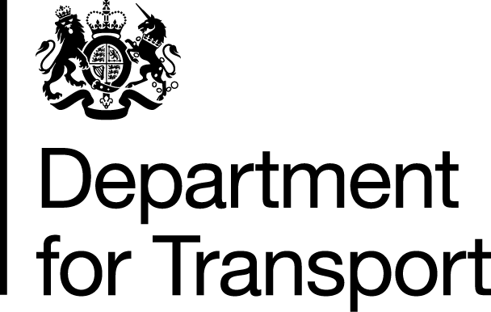

Welcome to the October 2017 edition of the Road Safety Newsletter. This newsletter has been written for the benefit of those working in the road safety field or who are interested in the topic.
Learner drivers on motorways
A public consultation was carried out earlier this year on allowing learner drivers to have lessons on motorways. The feedback received was mostly positive and the response to the consultation was published along with the Minister’s announcement to introduce this change on 13 August 2017. Under the proposals, learner drivers will be permitted to drive on motorways, when accompanied by an Approved Driving Instructor, in a dual-controlled car. The changes are due to come into force in 2018.
Closed-road motor racing
New laws came into force on 10 April 2017 which will allow motor racing events to take place on closed public roads in England.

The move could see small races hosted by local communities, bigger European rallies or even a future Monaco-style Grand Prix in an English city, offering economic benefits to local communities.

The Motor Sports Association which governs motor sports in the UK, and Auto Cycle Union which regulates motorcycle racing, will be authorised to issue permits for the races. They must consult the council, police and other local bodies and be fully satisfied that the event will be safe. Local authorities have the final say over whether a race can go ahead, and may require additional safety measures before, during or after the event as a condition of allowing a race to take place.

The government consulted on changing the law to allow racing on British roads in 2014. There were 6,077 responses from individuals, local authorities, police forces and other organisations, with an overwhelming majority in favour of the proposals.

Drug Driving

On 27 August, two Government-commissioned drug driving reports were published.

The first report evaluates the effectiveness of the drug driving offence introduced in March 2015, during the first year of implementation. In particular, the research analysed: operation and enforcement, public attitudes and awareness, convictions and road collision data.

The evaluation found that the Government legislation on drug driving is working. The new offence has led to additional police activity against drug drivers, and higher prosecution and conviction rates. In 2015, 1,442 motorists in the UK – about 4 a day – were convicted for offences, including being in charge of, attempting to drive, or causing death after exceeding the legal drug limit. Additionally, the laws are also disrupting wider criminal behaviour, according to the police. Two-thirds of all people convicted of drug driving have previously committed a crime.

The second report is an expert panel review of the available evidence for alternative methods that may be used as evidential samples of drug driving in the future. The panel noted that blood remains the ‘gold standard’ for detecting levels of drugs in the body, however it provides some recommendations for alternative methods which may be used in the future, including oral fluid and hair testing.

DfT will be considering the findings and recommendations from these reports as part of future work to strengthen drug driving law.

Publication of research reports
The Department published a number of road safety research reports on 27th August this year. They were:
• A review of retesting and educational interventions for serious driving offenders, which evaluates retesting for serious driving offenders. Under Section 36 of the Road Traffic Offenders Act, 1988, those convicted of a driving offence may be disqualified, and may be required to pass a practical driving test to regain their licence
• An evaluation of fixed penalty notices for careless driving, which looks to understand and measure the effectiveness of the Fixed Penalty Notice (FPN) for careless driving offences since its introduction in August 2013
• A review of interventions to increase the safety of young and novice drivers, which investigates the effectiveness of a range of interventions to improve safety for this higher risk group of drivers.
• An evaluation of the new drug driving legislation, one year after its introduction, which assesses the implementation and operation of the new drug driving legislation
• An expert panel review of alternative biological matrices for use as an evidential sample for drug driving, which provides recommendations on an alternative biological matrix that could be used as evidence for the new drug driving offence.
Mutual recognition of driving disqualifications with Ireland
The Mutual Recognition of Driving Disqualifications between the United Kingdom and the Republic of Ireland is provided for by way of Agreement on the Mutual Recognition of Driving Disqualifications between Ireland and the United Kingdom of Great Britain and Northern Ireland (“the Treaty”) signed on 30 October 2015.

This replaces the 1998 European Convention on Driving Disqualifications which the UK opted out of as part of the block opt-out from the Treaty of Lisbon on 1 December 2014. The Convention in any case has ceased to apply in European law. The Criminal Justice and Courts Act 2015 amends the Crime (International Cooperation) Act 2003 (“CICA”) which now directs to the Treaty as the legal basis by which this can happen. The Specified Agreement on Driving Disqualifications 2017 commenced this powers and came into force on 1 August.

Any driver resident in Great Britain or Northern Ireland, disqualified from driving for an offence committed in Ireland, would also be disqualified from driving in the other GB jurisdiction. Likewise a driver resident in Ireland, disqualified from driving for an offence committed in Great Britain or Northern Ireland, would be disqualified in Ireland. Mutual recognition of driving disqualifications between Great Britain and Northern Ireland has been in effect since October 2004.

The arrangements cover 6 categories of driver behaviour or conduct.

1) Reckless or dangerous driving (MR09)
2) Hit and run driving (MR19)
3) Driving whilst under the influence of alcohol/drugs (and refusal to submit to a test) (MR29)
4) Speeding (MR39)
5) Driving whilst disqualified (MR 49)
6) Other road traffic offences resulting in a disqualification period of 6 months or more). (MR59)

Important Points

Conduct which gives rise to the disqualification may be covered by the Convention and therefore by the arrangements, even if the offence committed is not an offence in the UK.

Disqualifications as a result of accumulating penalty points (“totting up”) are not included in the arrangements.

Cycling and Walking Investment Strategy

In April’s newsletter we highlighted the draft Cycling and Walking Investment Strategy and its ambition of making cycling and walking the natural choice for short journeys or as part of a longer journey.

Well the Cycling and Walking Investment Strategy was published in April 2017. It is a major milestone and shows that the Government is serious about promoting active travel

The challenge now moves to delivery. The Department for Transport will work closely with local authorities and others to ensure that we make good progress towards the Strategy’s aim, objectives and targets.

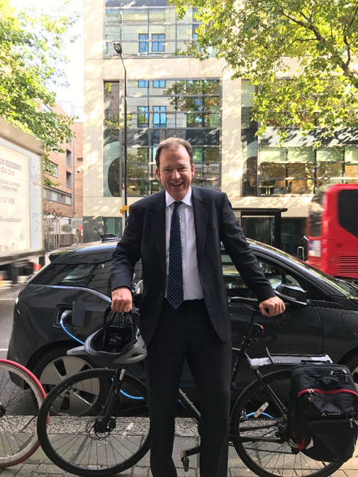

To support the Strategy, guidance for Local Transport Authorities (LTAs) on how to develop Local Cycling and Walking Infrastructure Plans (LCWIPs) has been published.

What is a LCWIP?

A LCWIP is a long-term plan for developing a cycling and walking network at the local level. By taking a strategic approach to improving conditions for cycling and walking, LCWIPs will enable LTAs to establish a pipeline of infrastructure improvements for delivery over the short, medium and long term. This can only be good for cyclists, walkers and everybody else!
Developing a LCWIP will also help ensure that consideration is given to cycling and walking within both planning and transport policies and strategies at the local level.

LCWIP Guidance

The LCWIP guidance provides LTAs with a step-by-step guide to planning a cycling and walking network and prioritising schemes for delivery. The guidance will include advice on establishing future potential demand for trips by foot and by bike, identifying routes for improvement and developing schemes. Alongside the LCWIP guidance, a suite of tools to help with the development of plans will also be made available, including a National Propensity to Cycle tool, which enables areas of high cycling propensity to be identified at the local level. A directory of design guidance will also be published to encourage high quality infrastructure solutions.

Practical Support

To support LTAs with the production LCWIPs a package of practical support will be made available alongside the guidance. This will include resources to support the development of LCWIPs as well as access to training and workshops focused on sharing of knowledge and lessons learned through delivery.
Major Road Network Consultation
Later this year, the Department will launch a consultation on the Major Road Network (MRN) policy that was announced as part of the Transport Investment Strategy.

The creation of an MRN will dedicate significant funding to improve a middle tier of our busiest and most economically important local authority ‘A’ roads, which sit between the national Strategic Road Network and the rest of the local road network.

The MRN will improve the productivity and connectivity of towns and cities across the country – helping people get to work or school and improving business links.

The consultation will provide further details about the development of our MRN policy, its links with wider policy areas such as road safety as well as proposed next steps in the creation of a MRN across England.

ASA Ruling on Aviva Insurance

In January 2017 Aviva ran three advertisements as part of their campaign to promote their driving app. The ads showed a variety of extreme bad driving behaviour with the message that safer drivers should not have to pay for other peoples’ bad driving, but should be rewarded.

The ads received 58 complaints suggesting that they were encouraging dangerous and irresponsible driving.

Aviva responded by broadcasting a variation of the ad to show less extreme driving and clarify the message about the Driving App being promoted which offered safer drivers a potential discount on their insurance.

The ASA ruled that the ads should not run even in their current form as they still encouraged dangerous and irresponsible driving. Further information on this can be found at:
https://www.asa.org.uk/rulings/aviva-insurance-uk-ltd-a17-396554.html
News from our Stakeholders

Road Safety Support International (RSSi) Recognised for the Prestigious Queen’s Award for Enterprise in International Trade

Road Safety Support International an organisation which strives to reduce the number of those being killed and seriously injured on roads across the globe has been recognised for their work though the Prestigious Queens Award for Enterprise In International Trade.

The organisation, which started just ten years ago is based in the UK. It specialises in the development of international road safety strategies and training; with a particular focus on the enforcement element of road safety improvements.

Although a small organisation; staff numbering around 20; RSSi have assisted a number of organisations in Hong Kong, Malaysia, USA, Trinidad and Tobago, Australia, Moldova, Kazakhstan, Turkey, Russia and Saudi Arabia to develop robust and effective road safety strategies that supports communities.

RSSi’s recent work in Kuala Lumpur, Malaysia and Victoria, Australia were two projects of note, leading to a large increase in overseas trade. Working with the Department of International Trade RSSi have developed a unique market identification tool that helped direct them towards new opportunities.

Trevor Hall, Managing Director states “We are delighted that the hard work, dedication and commitment of our staff has been recognised. Each individual who works for RSSi has one focus; that is to reduce the number of people being killed needlessly on the roads. To each of us, this is more than just a job, keeping people safe on the roads is something we truly care about. By working with and supporting police forces, government and third sector organisations both nationally and internationally; ultimately we are supporting people and communities.”

Mr Hall is widely regarded as one of the world’s leading independent experts on road safety, enforcement and technology. He is a RoadSafe Director and he represents the organisation at the UN Road Safety Collaboration meetings. He is a special advisor to the US Government on highway safety and enforcement issues.

Adam Briggs, Director commented, “The Queen’s Awards scheme is regarded as the most prestigious business awards in the country and we are thrilled that the work of RSSi has been recognised in this way. This is a rewarding job, though at times it can be difficult, especially when talking to those who have lost loved ones in road collisions. It is a pleasure to work with such committed people and winning this award is a tribute to that commitment.”

Mr Briggs has considerable international experience on road safety and security matters.

For further information please contact:-
Emma Kelly Business Development & PR Manager
Emma.Kelly@roadsafetysupport.co.uk
AND FINALLY……


Thank you RSSi for providing our first ‘News from our Stakeholders’ article. If you would also like share some news with our readers or provide an article for a future edition of the newsletter please email Sandra Forde at the email address below.

If you would like to be added to, or deleted from, the email list for this publication, please contact sandra.forde@dft.gsi.gov.uk

